
REVIEWS
WINE ADVOCATE
JUNE 2015

RAVENTOS I BLANC

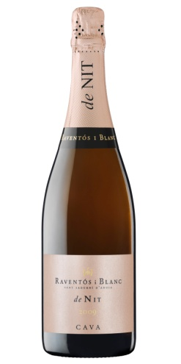
De Nit Brut Rose 2013 || 91 points
“The 2013 De Nit is a blend of the three classical white grapes from the region, Macabeo, Xarello, Parellada and a pinch (5%) of red Monastrell sourced from the historical Viña de la Plana. The wine had an average of 24 months in contact with the lees (18 for the first disgorgement and up to 30 for the last bottles before they finish the vintage and start with a new one). The color is extremely pale (it could even pass as a Blanc de Noir) and the nose is very similar to the 2013 L'Hereu, perhaps not as fine, with very nice, clean fruit. The palate might have a little more weight, with faint flower notes, very good acidity and a little bit of tannin coupled with acidity that gives it length and persistence and a distinct elegant rusticity. I'm not a great fan of pink sparkling wine in general, but I'm a fan of this one. This is a perfect aperitif wine.”

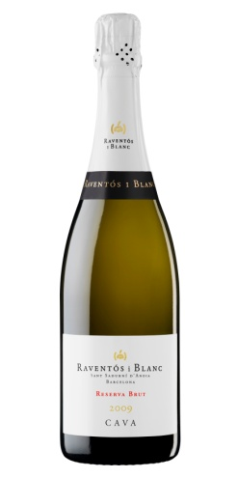
L’Hereu Brut Reserva 2013 || 91 points
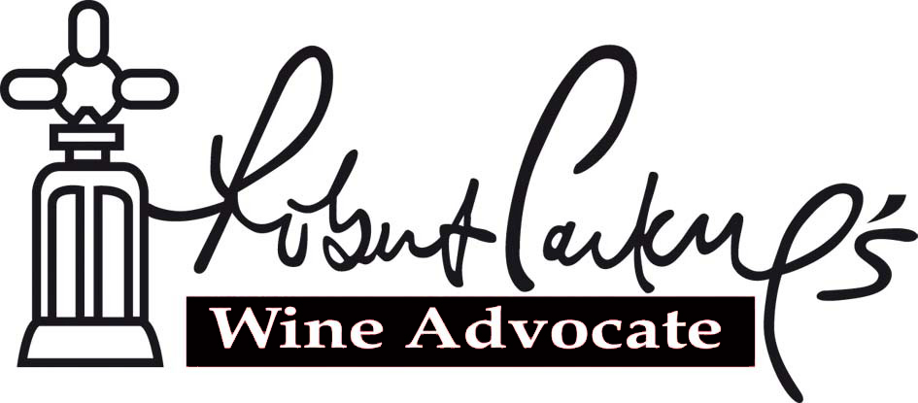
“The 2013 L'Hereu Brut is produced from what Pepe Raventós considers a great vintage that will be considered historic in the future. That year they harvested 25 days later than the recent average, so the grapes had time to ripen slowly to perfection with a long cycle that also held acidity and the wines are very fresh. This is sourced mostly form the Viña de la Plana, which has plenty of clay on the chalky mother rock (120 centimeters below) and quite deep soils that produce wines of good freshness and balance. They also use part of purchased grapes from organic growers as their idea is to keep some 20% of grapes from external suppliers. They like to work with some of the old-timers, the local people that know and understand the zone. The wine blends the three traditional grapes, Macabeo, Xarello and Parellada and ages no less than 18 months in contact with the lees (with a maximum of 30 and an average of 24). It is Extra-Brut (five grams of residual sugar). The powerful and expressive nose is really fresh, mixing fennel, aniseed, bread dough, in a very balanced, elegant and subtle way. The palate is extremely fresh (the signature of the vintage) and balanced with amazing weight of fruit, the lees/yeasts do not overpower the fruit and the finish is very long. This is one of the best sparkling wines in its category and price range, especially in this vintage.”
Reviewed by Luis Gutierrez || www.vselections.com

